**LAB # 4**

**Lab Task**

**Output:**

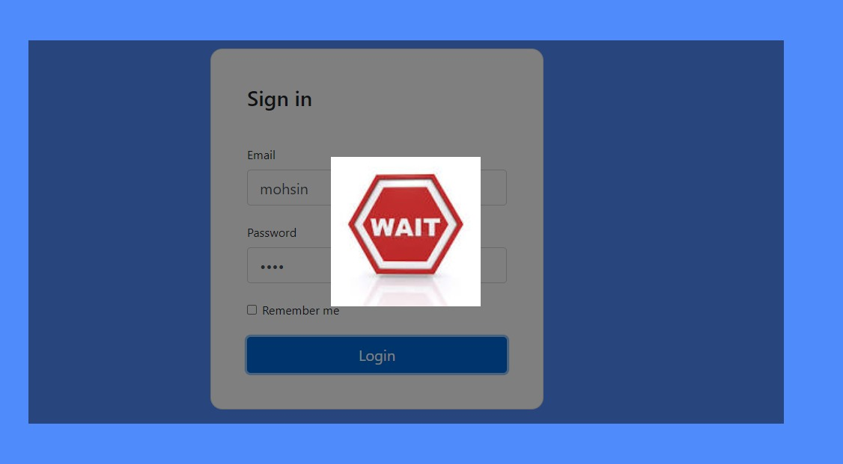

## Home Task

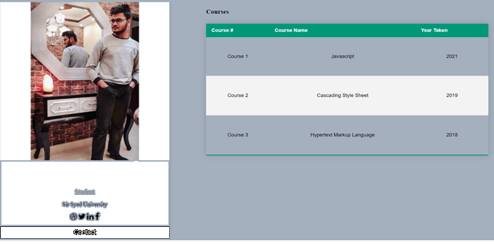

GIT HUB LINK:

<https://github.com/wajinaqvi/lab4>

https://github.com/hateemali/lab4

https://github.com/shahmirjilani /lab4